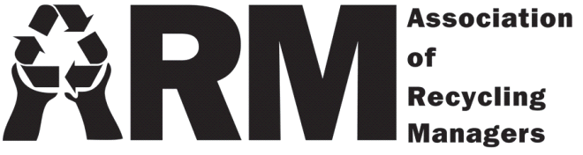

Membership Registration

Organization: Click or tap here to enter text.
Name: Click or tap here to enter text.
Address: Click or tap here to enter text.
Email: Click or tap here to enter text.
Phone: Click or tap here to enter text.
Date: Click or tap to enter a date.

One-Year Membership Fee: $15.00
Workshop Registration Fee: N/A

Total: $15.00

Payment Options:

- Check – Make all checks payable to Association of Recycling Managers and mail to:
Gena Gerard (ARM Treasurer)
c/o Dakota County Environmental Resources
14955 Galaxie Avenue
Apple Valley, MN 55124

- Credit card – Online payment for workshop registration only, subject to an additional processing fee

- Electronic Fund Transfer: - Account information for the Association of Recycling Managers is as follows:
Routing Number: 091000019
Account Number: 561202070
EIN Number: 41-1608423

Questions:
Please contact ARM Treasurer Gena Gerard, c/o Dakota County Environmental Resources
Phone: 952-891-7021
Email: gena.gerard@co.dakota.mn.us

PO Box 390151, Minneapolis, MN 55439
www.mnarm.org
associationofrecyclingmanagers@gmail.com

